Network Perimeter Lab
CYBR3010
Cybersecurity Foundations

Arr Domingo
Student ID: 200458099
December 2025

Instructor: Sam El-Awour
Table of Contents
1 Introduction 1
2 Scenario Overview 1
2.1 InnoEng acquisition of STE (Secure Tech Engineering) 1
2.2 Existing network of STE and key vulnerabilities 1
2.3 InnoEng network infrastructure requirements 2
2 Network Diagram 4
3 Rebuild and Configuration Guide 5
3.1 Building the lab in CML 5
3.1.2 Power on the VM environment 5
3.1.2 Lab setup in CML 6
3.2 Switch configuration – VLAN and Layer 2 security 7
3.2.1 Access the switch console 7
3.2.2 Implement VLAN for every department 8
3.2.3 Trunk port configuration (e0/0) 10
3.2.4 Access port configuration (e0/1, e0/2, e0/3, e1/0) 11
3.2.5 Apply layer 2 security controls – Port Security 16
3.3 FortiGate Firewall configuration – Interfaces, DHCP, Routing 17
3.3.1 Access FortiGate firewall UI (user interface) 17
3.3.2 FortiGate firewall (FW01) port1 connects to WAN/Internet (Bridge0) 20
3.3.3 FortiGate firewall (FW01) port3 connects to Windows Server 2019 (Bridge1) 21
3.3.4 FortiGate firewall (FW01) port2 connects to LAN/IOL-L2 switch (SW01) Ethernet0/0 22
3.3.5 Create VLAN in FortiGate firewall port2 for VLAN switch 24
0.3.1 Implement Active Directory Services (?? Build Windows Server (Domain Controller) Environemnt) 31
Task 3.1.1 Download and Install Windows Server 31
Task 3.1.2 Build and Configure a New Virtual Machine 32
Task 3.1.3 Prepare Server for Active Directory 36
Task 3.1.4 Install Active Directory Domain Services 40
Task 3.1.5 Promote Server to a Domain Controller 44
3.2 Centralized Network Authentication 49
Task 3.2.1: Prepare Windows 10 Client 49
4 Install FSSO_Setup (Fortinet Single Sign On) on the Windows server 2019 in VMWare to associate firewall and domain controller 50
4.1 Assuming FSSO_Setup is downloaded in local machine, to transfer files from local machine (host) to a Windows Server 2019 VM in VMware Workstation Pro 50
4.2 Access the FSSO_Setup in the shared folder and install 51
4.3 Open the Fortinet Single Sign On window 53
Check connection of Windows Server and Fortinet firewall 55
Adding Policies/Rules in Fortinet Firewall (8:26 in VIDEO) 56
Question and Answer 57
4.1 What is meant by “network perimeter defense” in modern enterprise networks? Explain how the traditional concept of a perimeter has evolved with cloud adoption, remote work, and mobile devices. 57
4.2 Compare the capabilities of a Next-Generation Firewall (NGFW) with those of a traditional Layer 3/4 firewall. Highlight features such as application awareness, intrusion prevention, SSL inspection, and user-based policies. 58
4.3 How can NGFWs leverage threat intelligence feeds for proactive defense? Discuss the potential benefits and risks of relying on third-party threat intelligence in firewall policy decisions. 59
4.4 How can NGFW policies support a Zero Trust security model? Explain how concepts such as micro-segmentation, least privilege, and continuous verification can be applied at the perimeter level. 59
References 1

1 Introduction
This document is about network security after a merger or acquisition which emphasize the use of firewall to protect the internal network and create demilitarized (DMZ) zone for public-facing services. The purpose is to set-up security measures in a computer network, how the network operates, security considerations and standards, and the prototypes associated with a range of networking technologies. Additionally, this document will configure and install an integrated, real-time and attack prevention using Next-Generation Firewall (NGFW), VLAN segmentation, and an Active Directory (AD)–integrated identity infrastructure.

2 Scenario Overview

2.1 InnoEng acquisition of STE (Secure Tech Engineering)
InnoEng, officially known as Innovative Engineering Ltd, is a prominent global leader specializing in design and engineering solutions. InnoEng has recently embarked on an expansion initiative by acquiring Secure Tech Engineering (STE), which is a smaller engineering firm with a strong focus on technology and innovation, situated in Edmonton, Alberta. This acquisition marks InnoEng's venture into the Western Canadian market.

2.2 Existing network of STE and key vulnerabilities
The current network of STE consists of:
- Three departments namely, Engineering department, Finance department, HR department.
- A flat domain using an unmanaged network switch.
- Staff desktops and the server on the same subnet.
- A router with limited security capabilities.
Despite the functionality of the existing network infrastructure setup, the system lacks protections and would expose the organization to significant risks. Below are the key vulnerabilities of STE’s existing network infrastructure.
- Lack of segmentation: A compromise on any endpoint could lead to lateral movement to servers and other departments with minimal resistance.
- No identity-based controls: Access was based on IP addresses only, not on user roles or groups (e.g., HR vs Engineering).
- Limited visibility and logging: Traditional router logging provided little insight into applications, users, or threats (Stallings, 2020).
- Uncontrolled management access: Network equipment was potentially reachable from any host, increasing the risk of misconfiguration or abuse.

2.3 InnoEng network infrastructure requirements
Since the existing network setup of STE has some sort of vulnerabilities, it needs to implement an additional requirement to fully protect the network infrastructure before it is given to InnoEng IT staff to support and further maintain. Below are the requirements.
- Segmented Network:
- Engineering Department (VLAN 10 - InnoEng)
- Finance Department (VLAN 20 - InnoEng)
- HR Department (VLAN 30 - InnoEng)
- Firewall:
- Essential configurations including interfaces, IP addressing, DHCP, and routing.
- Only Active Directory–authenticated “HR” staff accounts are permitted to communicate with Finance department systems; all other inter-departmental communication is blocked.
- Bandwidth usage for the Engineering Department is capped at a maximum of 3 MB/s.
- Access to the firewall web console is restricted exclusively to systems within the IT Department.
- Enable a minimum of two Next-Generation firewall features and demonstrate their impact on network traffic.
- The SSL inspection certificate is distributed to clients via Group Policy Object (GPO).
- Logging for firewall events and security incidents is enabled.
- All policies must clearly define network traffic criteria, including IP addresses, address ranges, protocols, applications, and content types, in accordance with organizational information security standards. Configurations should use precise matching conditions to grant only the necessary access while denying all other traffic.
- Switch: Configured with the necessary VLANs to enable local network connectivity, ensuring network segmentation, and implementing suitable layer 2 security measures.
- Windows Server: Setup with DC with Active Directory services domain environment (Domain named after student’s last name).
- Staff Desktops: All InnoEng systems are integrated into the domain, using secure Active Directory user logins.
Considering all the requirements, therefore, there is a need to plan, design, and implement a new network diagram to secure the network system of InnoEng.

2 Network Diagram
This is the network layout base from the requirements given by InnoEng, which consists of virtual firewall, Windows server virtual machine with AD DS role installed, virtual network switch, and three client virtual machines representing different departments such as Engineering, Finance, and HR.
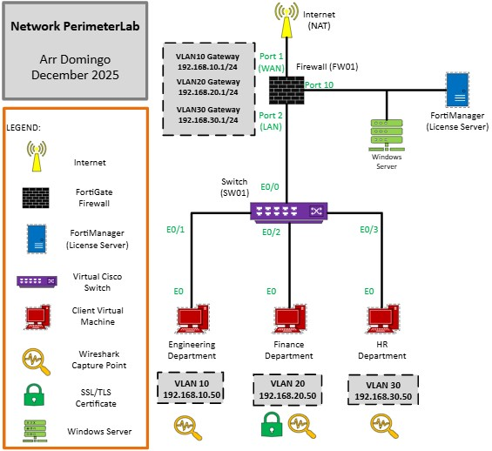
Figure 1. Network diagram of network perimeter lab. ---change this

3 Rebuild and Configuration Guide

3.1 Building the lab in CML

Power on the VM environment
- For FortiManager VM environment:
  - Click "Power on this virtual machine".
  - Wait for couple minutes until it reaches the "FortiManager login", leave it like that, just keep the image open.
- For CML VM environment:
  - Click "Power on this virtual machine".
  - You will see an IP address to access CML UI. Note that it is different for everybody depending on your setup.
  - Open a browser and paste the IP address. If the browser is not allowing it, click the "Advanced" and proceed.
  - On the login page, "admin" is the username and "P@ssw0rd25" is the password.
  - Right off the bat, you will see your CML dashboard where you can add projects/lab. Below the screen, you will see the health data which includes the CPU, Memory, and Disk, as well as the licensing.

Lab setup in CML
- On the CML screen, click “Add”.
- You will then proceed to the lab dashboard environment where you can see the workbench consisting of different tools to complete the lab.
- At the top of the screen where you see a dropdown icon, rename the "Lab Title". "Lab Description" is optional.
- The most important tool in the workbench is the "Add Nodes" where you can add network resources such as firewall, switch, router, desktop machine, etc. For this network infrastructure setup, add the following nodes:
- Three External Connectors: Internet/WAN (Bridge0), FortiManager License (Bridge1), Windows Server 2019 (Bridge1)
- One FortiGate firewall (name: FW01)
- One IOL-L2 switch (name: SW01)
- Four client virtual machines
- Connect the following:
- FortiGate firewall (FW01) port1 WAN/Internet (Bridge0)
- FortiGate firewall (FW01) port10 FortiManager License (Bridge1)
- FortiGate firewall (FW01) port3 Windows Server 2019 (Bridge1)
- FortiGate firewall (FW01) port2 LAN/IOL-L2 switch (SW01) Ethernet0/0
- Client virtual machines IOL-L2 switch (SW01) ports
- Engineering Department Ethernet0/1
- Finance Department Ethernet0/2
- HR Department Ethernet0/3
- IT Department Ethernet1/0
6. In VMware Workstaion pro??? P13

Switch configuration – VLAN and Layer 2 security

3.2.1 Access the switch console
- In CML, right-click the switch then press “Start”.
- Right-click the switch again then press “Console”.
- Click “Open Console”.
- In the console, type “enable” then press enter to enter the privileged EXEC mode.
- Type “configure” then press enter to enter the global configuration mode.
- If you see “Configuring from terminal, memory, or network [terminal]”, just press enter.
- Inside the config, type the word “hostname” plus name of the device to enter the device configuration, then press enter. Ex. “hostname SW01”.
- Type “exit”.
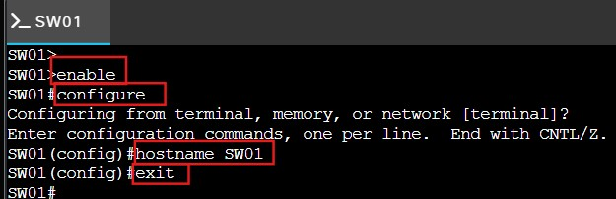
Switch command.

Implement VLAN for every department
- On the switch console, type “enable” then press enter to enter the privileged EXEC mode.
- Type “config” to configure the switch.
- Press enter when ask “Configure from terminal?”.
- Inside the switch config, type “vlan 10” and press enter.
- Type “name Engineering” to put a name on vlan 10 and press enter.
- Add another vlan which is “vlan 20” and press enter.
- Type “name Finance” and press enter.
- Another vlan which is “vlan 30” and press enter.
- Type “name HR” and press enter.
- Another vlan which is “vlan 99” and press enter.
- Type “name IT” and press enter.
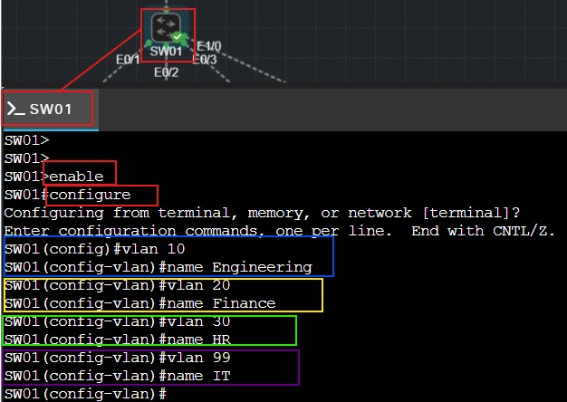
VLAN configuration in switch.
- Type “exit” and press enter.
- Type “exit” and press enter.
- Type “show vlan” to show lists of existing vlan.
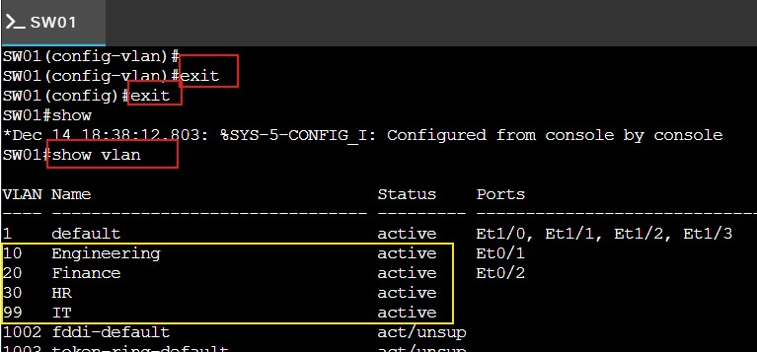
Verify list of VLAN.

Trunk port configuration (e0/0)
- Interface e0/0 will be used as the trunk uplink to the FortiGate firewall/LAN (FW01) port2 interface. Type “configure terminal” and press enter.
- Type “int e0/0” and press enter.
- Type “switchport trunk encapsulation dot1q” and press enter.
- Type “switchport mode trunk” and press enter.
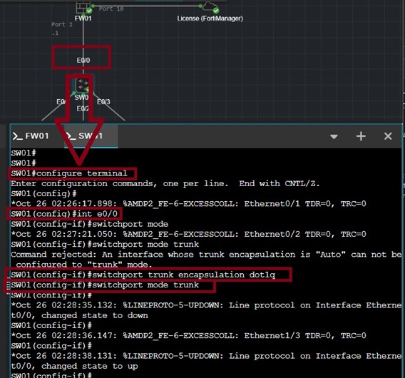
Commands in switch console to configure trunk port (e0/0).

Access port configuration (e0/1, e0/2, e0/3, e1/0)

- In the same switch configuration, type “int e0/1” and press enter.
- Type “switchport mode access” and press enter.
- Type “switchport access vlan 10” and press enter.
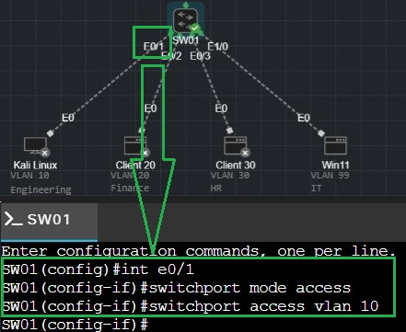
Commands in switch console to configure access port of e0/1.
- For e0/2, type “int e0/2” and press enter.
- Type “switchport mode access” and press enter.
- Type “switchport access vlan 20” and press enter.
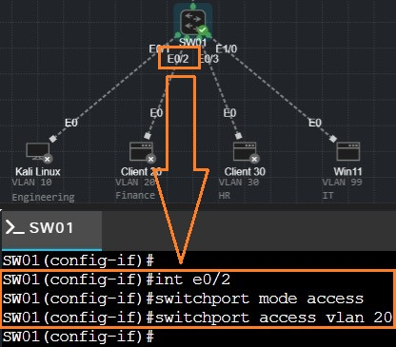
Commands in switch console to configure access port of e0/2.
- For e0/3, type “int e0/3” and press enter.
- Type “switchport mode access” and press enter.
- Type “switchport access vlan 30” and press enter.
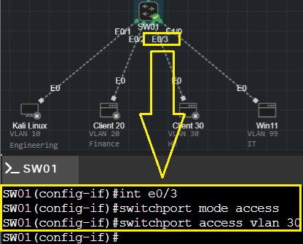
Commands in switch console to configure access port of e0/3
- For e1/0, type “int e1/0” and press enter.
- Type “switchport mode access” and press enter.
- Type “switchport access vlan 99” and press enter.
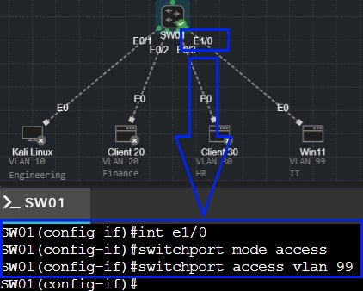
Commands in switch console to configure access port of e1/0
- Type “exit” and press enter.
- Type “exit” and press enter.
- Type “show vlan” and press enter to show lists of vlan together with the ports.
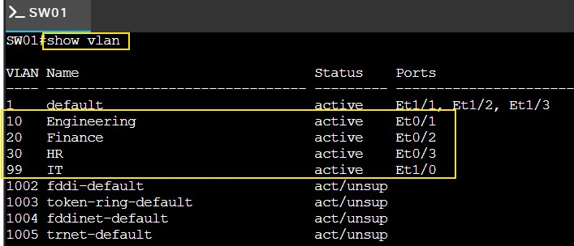
Lists of VLAN after the access port configuration.
- Finally, type “write” and press enter to save the configuration made.

Apply layer 2 security controls – Port Security
To prevent MAC flooding and MAC spoofing attack, use Port Security. Below are the main commands that would limit MAC addresses and block unknown devices.
- Make sure you are in SW01#, otherwise type “enable” and press enter.
- Type “configure terminal” and press enter.
- In the switch configuration, type “interface range e0/1-3, e1/0”and press enter. This command means going to interfaces range from e0/1, e0/2, e0/3, and e1/0.
- Type “switchport mode access” and press enter.
- Type “switchport port-security” and press enter.
- Type “switchport port-security mac-address sticky” and press enter.
- Type “switchport port-security maximum 2” and press enter.
- Type “exit” and press enter.
- Type “exit” and press enter.
- Finally, type “write” and press enter to save the configuration made.
- Type “show port-security” to check what is going on after the implementation of port security.
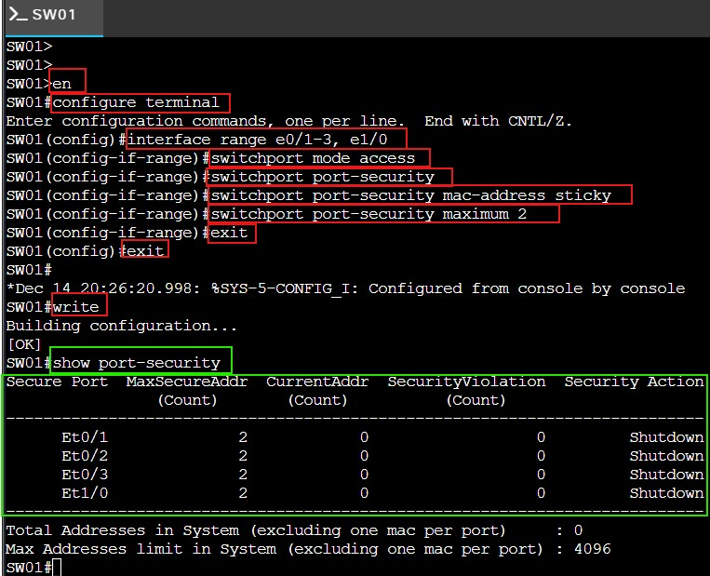
After the implementation of port security on access ports.

3.3 FortiGate Firewall configuration – Interfaces, DHCP, Routing

Access FortiGate firewall UI (user interface)
- In CML, start the firewall (FW01) as well as all other devices.
- Right click the firewall (FW01) and choose “Console”. You know firewall is done booting when you are able to see the serial number and the firewall login.
- Type “cisco” in the “Firewall login” and “Password”.
- Wait until you see “Welcome”.
- Type “get system interface physical port1” to get information about port 1 that is connected to the internet. Open the IP address in another browser.
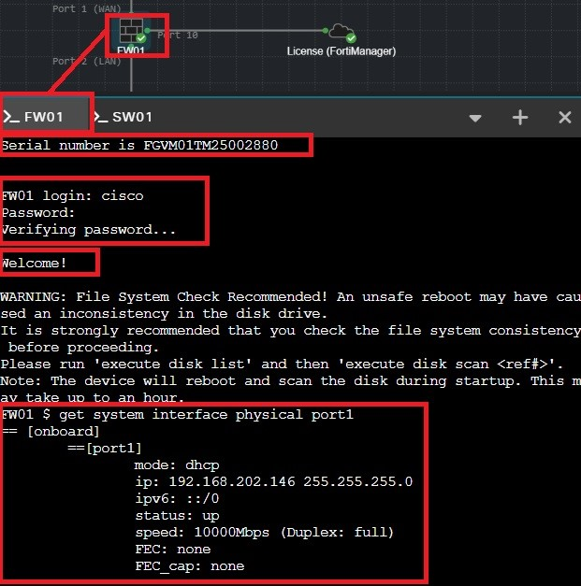
Steps to open FortiGate firewall UI.
- On the browser, click “Advanced”.
- Click “Proceed to 192.168.202.146(unsafe)”.
- Type “cisco” as the Username and Password, then click “Login”.
- Click "Login Read-Write".
- Click "Yes".
- Click "Begin".
- In the Dashboard Setup, choose the default which is "Optimal" and press "OK".
- Firewall (FW01) dashboard will open up.
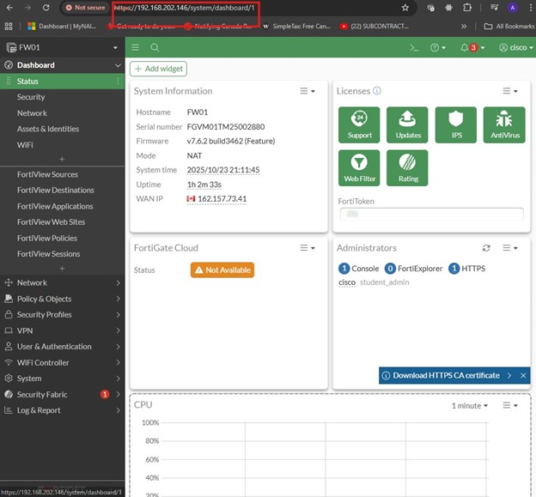
Firewall (FW01) dashboard.

FortiGate firewall (FW01) port1 connects to WAN/Internet (Bridge0)
- In the firewall (FW01) dashboard, click “Network”.
- Click “Interfaces”.
- Double click “port1” as this is the port connecting to Internet/WAN (Bridge0).
- On “Edit Interface” window, enter the following details:
- Alias: WAN
- Role: WAN
- Addressing mode: DHCP
- On IPv4, enable “PING”, “HTTP”, “HTTPS”
- Click OK.
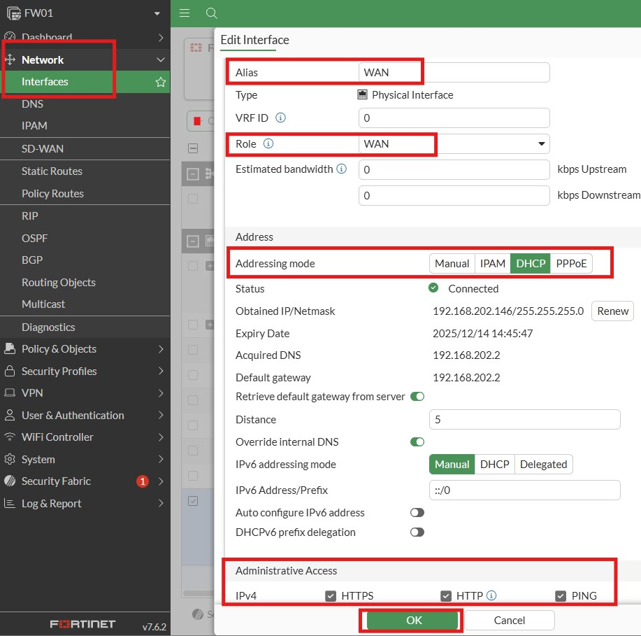
Configuration of port1 interface as WAN.

FortiGate firewall (FW01) port3 connects to Windows Server 2019 (Bridge1)
- In the firewall (FW01) dashboard, click “Network”.
- Click “Interfaces”.
- Double click “port3” as this is the port connecting to Windows Server 2019 (Bridge1).
- On “Edit Interface” window, enter the following details:
- Alias: Connection_Windows_Server
- Role: LAN
- Addressing mode: Manual
- IP/Netmask: 192.168.40.2/255.255.255.0
- On IPv4, enable “PING”, “HTTP”, “HTTPS”
- Click OK.
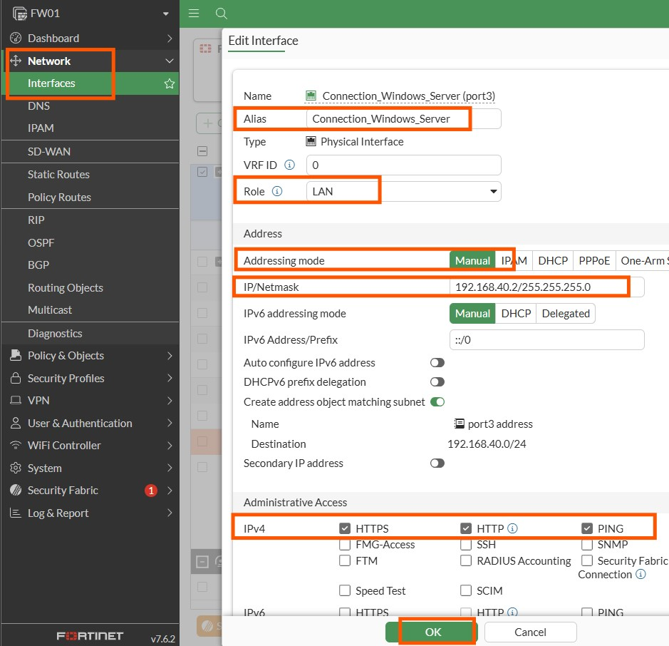
Configuration of port3 interface as the connection to windows server 2019.

3.3.4 FortiGate firewall (FW01) port2 connects to LAN/IOL-L2 switch (SW01) Ethernet0/0
- In the firewall (FW01) dashboard, click “Network”.
- Click “Interfaces”.
- Double click “port2” as this is the port connecting to LAN/IOL-L2 switch (SW01) Ethernet0/0.
- On “Edit Interface” window, enter the following details:
- Alias: LAN
- Role: LAN
- Addressing mode: Manual
- IP/Netmask: 0.0.0.0/0.0.0.0
- On IPv4, enable “PING”
- Click OK.
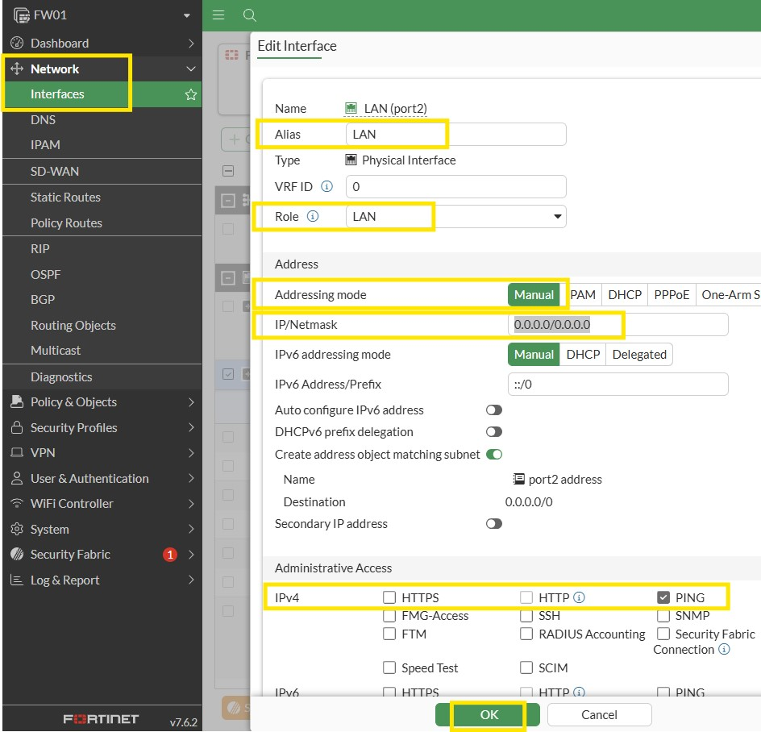
Configuration on port2 interface as LAN.

Create VLAN in FortiGate firewall port2 for VLAN switch
This section is to create four different VLAN interfaces under port 2 that can talk to each
department/VLANs created in the switch.
Table 1. Summary of VLAN configuration in FortiGate firewall.
Name | Alias | VLAN ID | IP/Netmask | Address Range
VLAN10 | Engineering | 10 | 192.168.10.1/24 | 192.168.10.50-192.168.10.200
VLAN20 | Finance | 20 | 192.168.20.1/24 | 192.168.20.50-192.168.20.200
VLAN30 | HR | 30 | 192.168.30.1/24 | 192.168.30.50-192.168.30.200
VLAN99 | IT | 99 | 192.168.99.1/24 | 192.168.99.50-192.168.99.200

- In the firewall (FW01) dashboard, click “Network”.
- Click “Interfaces”.
- Click “Create New” and click on “Interface”.
- On “New Interface” window, put “VLAN10” under “Name” (others are VLAN20, VLAN30, and VLAN99).
- “Alias” is “Engineering” (Finance for VLAN20; HR for VLAN30; IT for VLAN99).
- “Type” is “VLAN”.
- “VLAN protocol” is “802.1Q”.
- In “Interface”, choose “LAN(port2)”.
- “VLAN ID” is “10” (“20” for VLAN20; "30” for VLAN30; “99” for VLAN99).
- Click “Manual” in the “Addressing mode”.
- “IP/Netmask” is “192.168.10.1/24” (192.168.20.1/24 for VLAN20; 192.168.30.1/24 for VLAN30; 192.168.99.1/24 for VLAN99).
- Check “PING” on IPv4.
- Enable “DHCP Server”.
- Put “192.168.10.50-192.168.10.200” in the “Address range” (192.168.20.50-192.168.20.200 for VLAN20; 192.168.30.50-192.168.30.200 for VLAN30; 192.168.99.50-192.168.99.200 for VLAN99).
- Click OK.
- Repeat the process for VLAN20, VLAN30, and VLAN99.
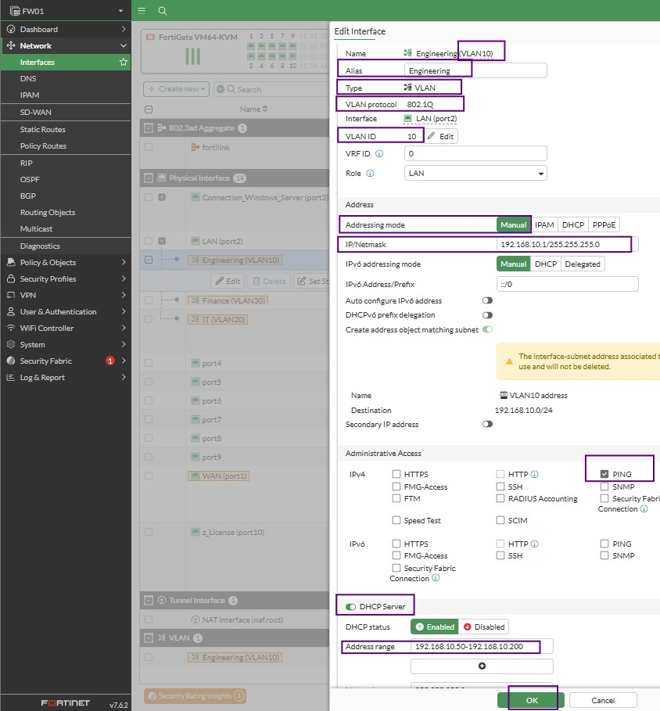
VLAN 10 (Engineering) configuration.
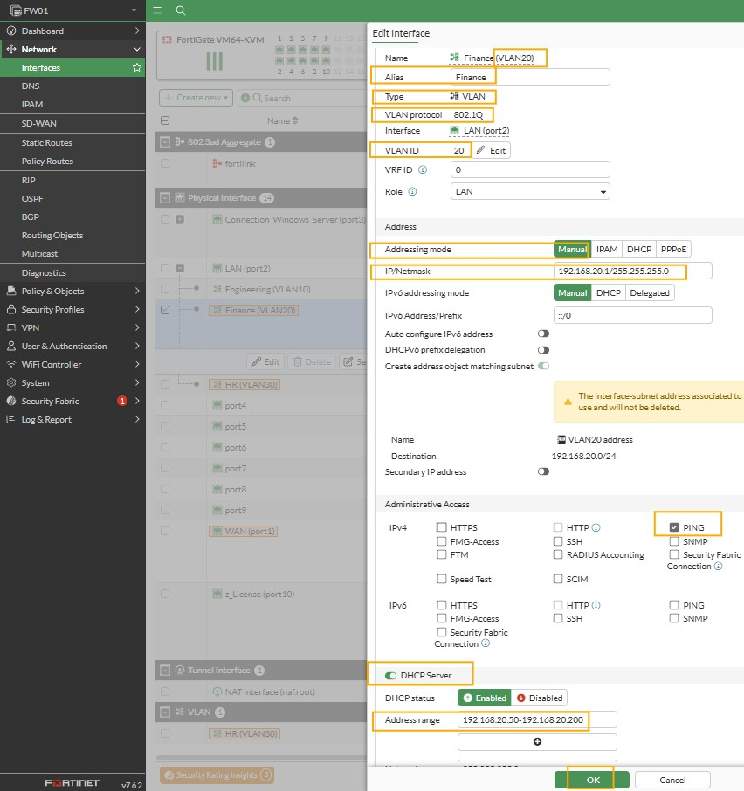
VLAN 20 (Finance) configuration.
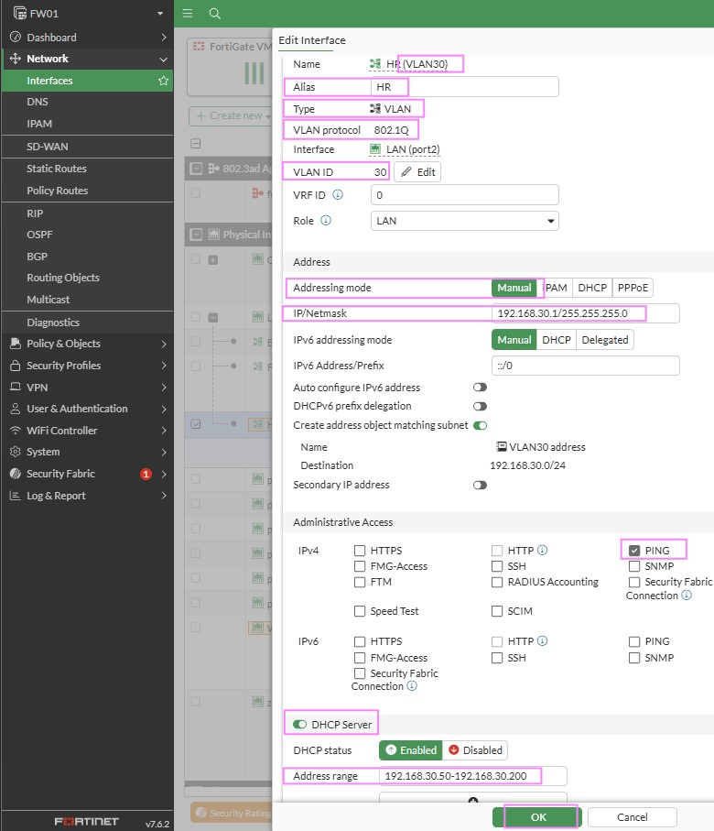
VLAN 30 (HR) configuration.
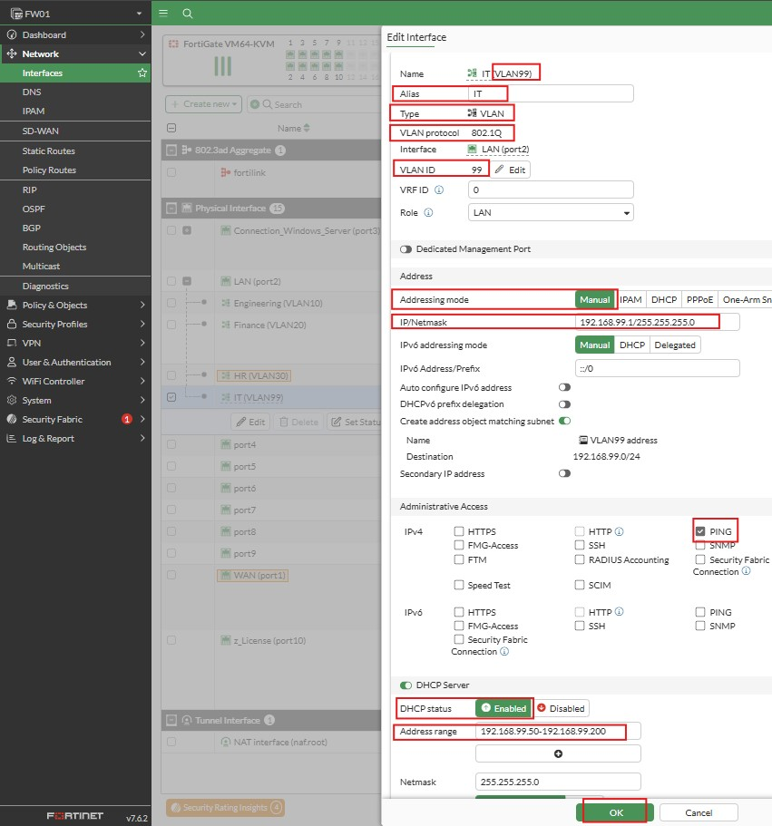
VLAN 99 (IT) configuration.
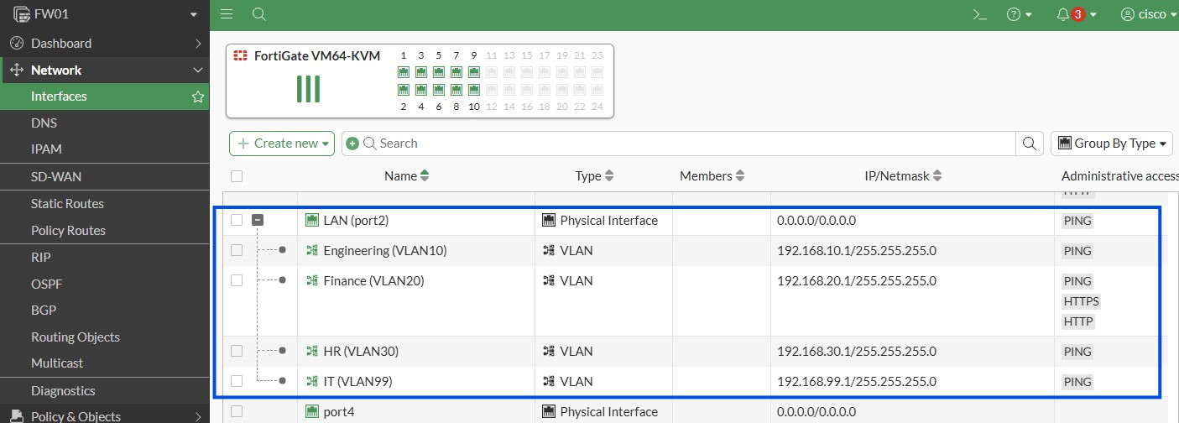
These are the 4 VLANS created in port2 FortiGate firewall.
- At this point, VLAN is now in place. It means VLAN10, VLAN20, and VLAN30 cannot communicate with each other anymore.

3.4 Windows Server 2019 Configuration

3.4.1 Download and Install Windows Server
- Download Windows Server 2019 Standard edition from the following website: https://aka.ms/devtoolsforteaching.
- Log in using your NAIT account.
- On the left panel, click on Software and search for "Windows Server".
- Download the Windows Server 2019 Standard edition. Remember the product key that will be generated using the “View key” button on the page.

3.4.2 Build and Configure a New Virtual Machine
- Open VMware Workstation Pro. Go to File and click “New Virtual Machine”.
- Select “Typical (recommended)” and click Next.
- Choose “I will install operating system later” and click Next.
- For the O/S, select “Microsoft Windows” and pick “Windows Server 2019” from the drop-down menu. Click Next.
- Enter a virtual machine name and store it in a memorable location. Click Next.
- Keep the default disk size and click Next.
- Click Finish.
- Click “Edit virtual machine settings”.
- Set the RAM to 4GB (4096 MB).
- On the left menu, click “CD/DVD (SATA)”.
- Select “Use ISO image file” and then click on Browse and select the ISO file you just downloaded.
- Then click on OK.
- You will be brought back to the main windows of VMware Workstation Pro. Click on “Power on this virtual machine” to begin the installation process.
- In the Windows Setup window, click Next.
- Click on Install Now.
- Type the product key, then click on Next.
- Select “Windows Server 2019 Standard (Desktop Experience)” then click Next.
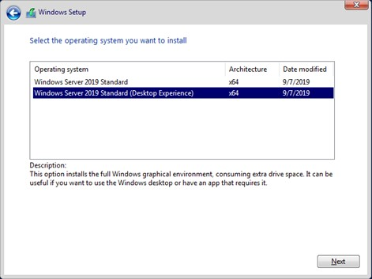
Windows Server 2019 Standard (Desktop Experience) as the operating system.
- Accept the license agreement, then click on Next.
- Select the second option for Custom: Install Windows only (advanced).
- Click on Next to select the entire disk space to install the O/S.
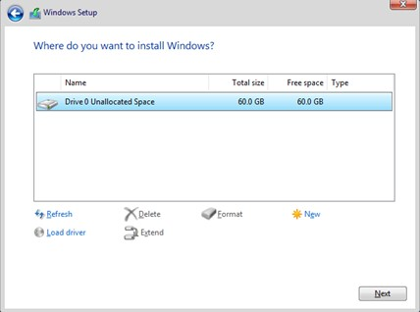
Disk space configuration.
- The installation will now be underway.
- Type a memorable password (qwerty01A.SERVER2019) for the built-in administrator account, then click on Finish.
- Log in to the server.
- If you see a message about allowing your PC to be discoverable, click Yes.
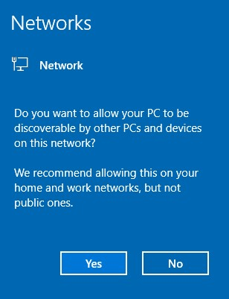
Allowing PC to be discoverable.
- In the Server Manager pop-up message, click on Don’t show this message again and then close the window.
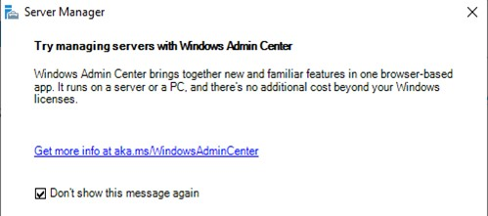
Server Manager message.

Prepare Server for Active Directory
- Install VMTools by going to VM menu then click “Install VMware tools”.
- A message will appear on VMWare screen or just go directly to D drive and look for the setup application. Run the setup and keep default. Restart the server.
- After you log in, the server manager dashboard will open automatically.
- On the left panel, click on Local Server, then click on the computer name. Let’s change it to SRV01.
- Click on Change.
- Type SRV01 and then click OK.
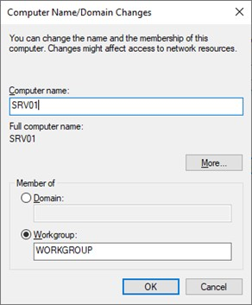
Set computer name to SRV01.
- A message will appear indicating a restart is needed. Click OK.
- Click on Close in the System Properties window.
- Finally, click on Restart Now.
- Log in to the server, open the command prompt, and find out your IP address, subnet mask, and default gateway. Make a note of this information.
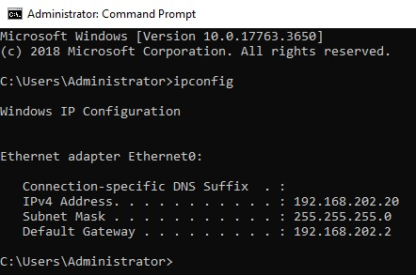
IP configuration of the server. - might delete this
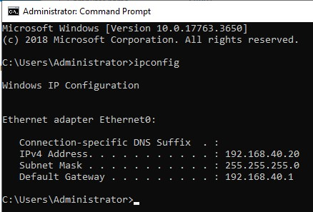

- Back on the Server Manager dashboard, click on Local Server on the left panel, then click on Ethernet0 to set up a static IP.
- Right-click on Ethernet0 and select Properties.
- Disable IPv6 to avoid communication issues. Select IP version 4, then click on Properties.
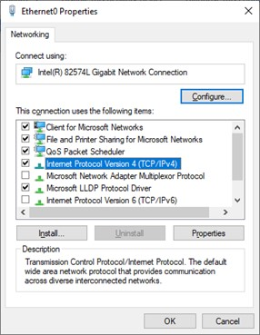
Ethernet0 properties.
- Set a static IP based on the information you noted. The static IP in the example is 192.168.40.20, but yours might be different. Make sure you set the preferred DNS server to the same as the static IP server because DNS will be installed on the same server. Click OK, then click Close.
- Back on the Server Manager Dashboard, refresh (F5) and you will notice the static IP.
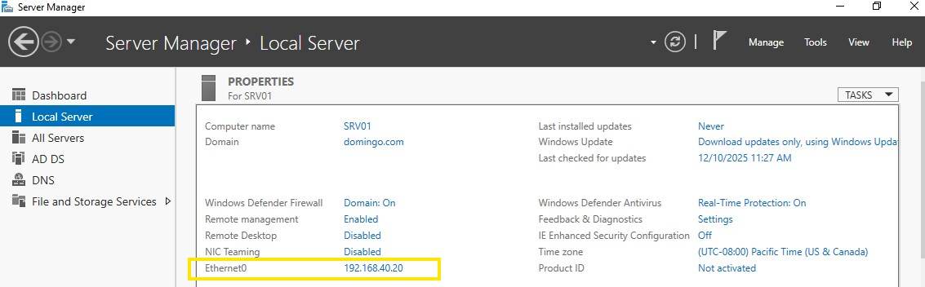
Confirmation of static IP had been set-up.
- Now the server is ready for Active Directory to be installed.

Install Active Directory Domain Services
- On the top right corner of the server manager dashboard, click on Manage > Add Roles and Features.
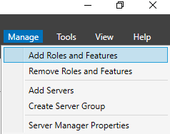
Add Roles and Features.
- Click Next on the "Before you begin" screen.
- Click Next to select "Role-based or feature-based installation".
- Click Next again.
- Select the second option, Active Directory Domain Services.
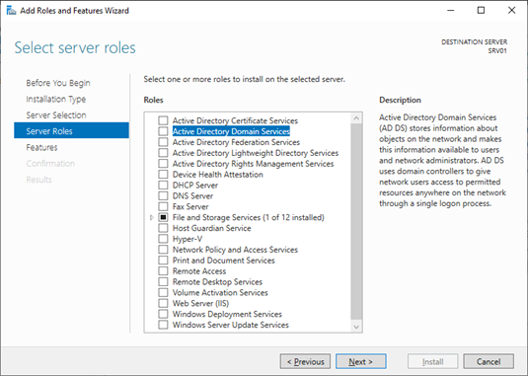
Selecting active directory domain services.
- In the pop-up message, click on Add Features.
- Click Next.
- Do not select additional features. Click Next.
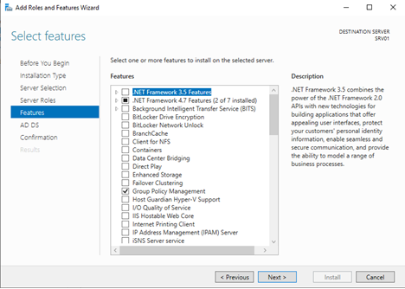
No additional features, just click next.
- The Directory Service installation will begin. Click on Next.
- Click on Restart the destination server automatically if required.
- You will see a warning message, click Yes.
- Then click on Install.
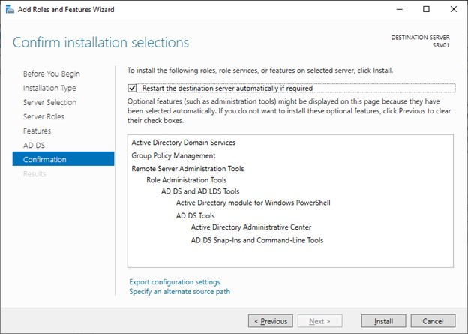
Click install.

Promote Server to a Domain Controller
- When the installation of Directory Services is over, click on Promote this server to a domain controller.
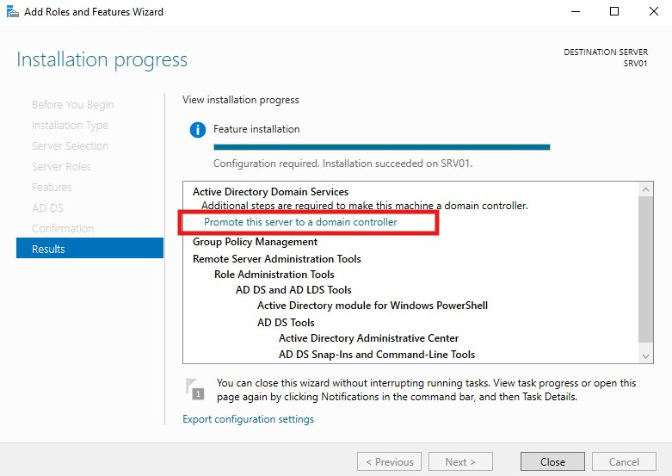
Promote server to a domain controller.
- Another setup window will appear. Click on Add a new forest and set the root domain to “domingo.com”. Click Next.
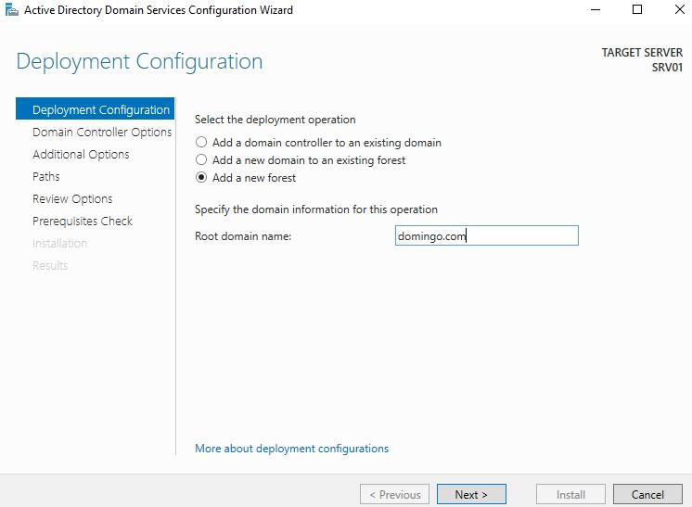
Root domain name.
- Set the recovery password (P@ssword01) twice to something memorable, then click Next.
- You will see a warning message indicating that a DNS zone was not found. Click Next and it will be installed automatically.
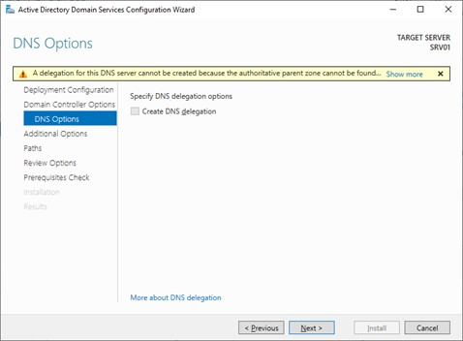
Warning message.
- The NetBIOS name will be populated automatically. Click Next.
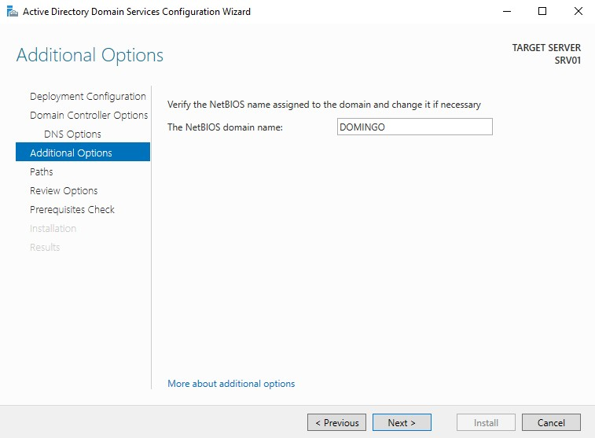
NetBIOS domain name will be populated.
- The location of the Active Directory database and log file will be displayed. Click Next.
- Click Next on the Review Options screen.
- Finally, click on Install.
- When the installation is over, the server will restart automatically. This might take a while.
- Log in to the admin account. The local administrator has now become a domain administrator and can access and administer any computer that is joined to the domain. Use the password you set-up in Task 3.4.2 (qwerty01A.SERVER2019).
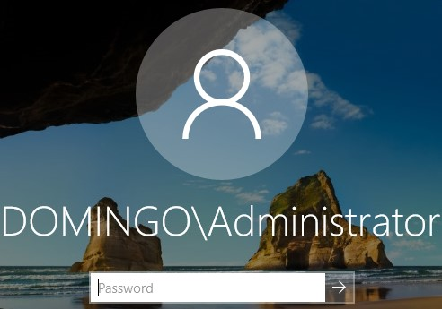
Logon screen showing domain administrator as DOMINGO\Administrator.

Create Organizational Units (OU)
- In the virtual machine, power-on Windows Server 2019 and login to the domain administrator (DOMINGO\Administrator).
- “Server Manager” will automatically open. Go to “Tools” and click “Active Directory Users and Computers”.
- On the left panel, expand domingo.com.
- Right-click the domain domingo.com New Organizational Unit.
- Create the following OU’s:
- InnoEng-Branches
- Under InnoEng-Branches, create STE-Edmonton
- Under STE-Edmonton, create:
  - STE-Computers
  - STE-Groups
  - STE-Users
- Under STE-Users, create specific sub-OU’s department:
- ENG-Users
- FIN-Users
- HR-Users
- IT-Admin-Users
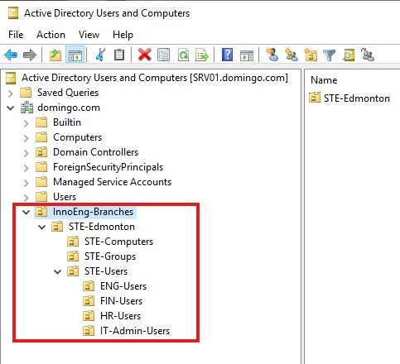
Organizational Units (OU).

Create Security Groups for Departments
Use global security groups to map the firewall policies and role-based access.
- In Active Directory Users and Computers (ADUC), right-click “STE-Groups” OU New Group.
- Create the following groups:
- Group name: ENG-Staff, Group scope: Global, Group type: Security
- Group name: FIN-Staff, Group scope: Global, Group type: Security
- Group name: HR-Staff, Group scope: Global, Group type: Security
- Group name: IT-Admins, Group scope: Global, Group type: Security
- Click OK after each group is created.
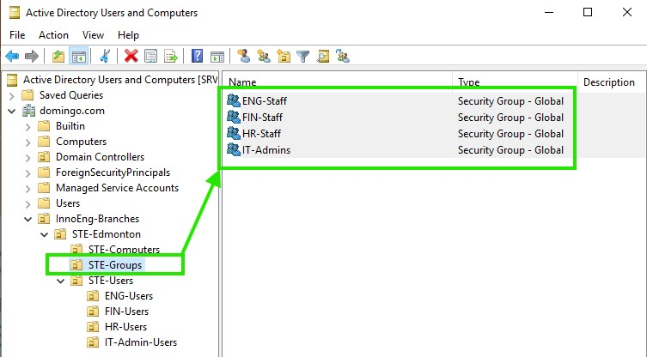
Security groups for departments.

3.4.8 Create User Accounts and Assign Group Membership
Create representative users for each department and assign them to the correct group.
- In Active Directory Users and Computers (ADUC), navigate to STE-Users ENG-Users.
- Right-click ENG-Users New User and create:
- First name: Eng
- Last name: User1
- User logon name: eng.user1
- Click Next.
- Set a password (P@ssw0rd25) then click Next.
- Click Finish.
- Right-click the new user eng.user1 Properties Member Of tab.
- Click Add and add them to ENG-Staff.
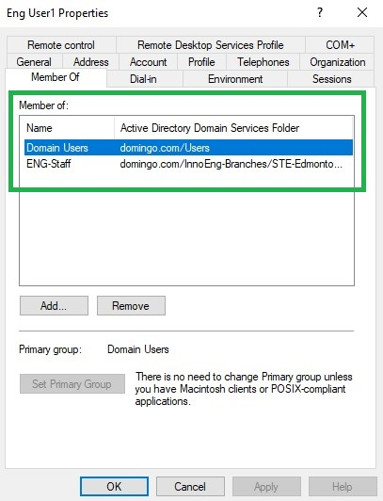
User properties showing Eng User1 is a member of ENG-Staff.
- Repeat the same steps for Finance, HR, and IT.
- Under FIN-User: create fin.user1 and add to Fin-Staff.
- Under HR-Users: create hr.user1 and add to HR-Staff.
- Under IT-Admin-Users: create it.admin1 and add to IT-Admins
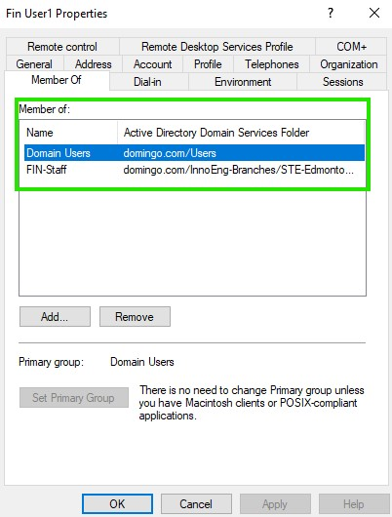
User properties showing Fin User1 is a member of FIN-Staff.
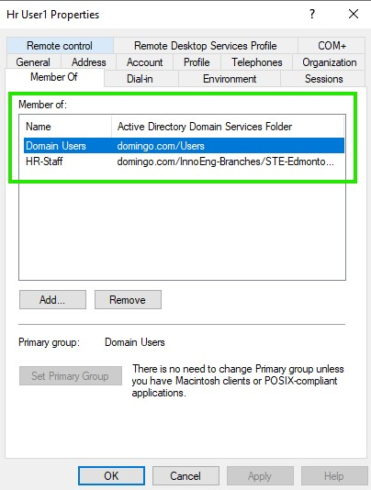
User properties showing Hr User1 is a member of HR-Staff
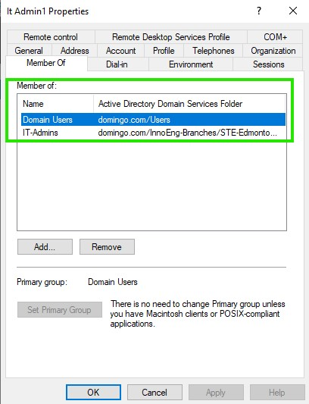
User properties showing It Admin1 is a member of IT-Staff

3.4.9 Install Fortinet Single Sign-On (FSSO) Agent
This is important so that FortiGate firewall can learn which user is logged in to which IP address and which AD groups they belong to. This will answer the InnoEng’s requirement for identity-based policies such as the HR → Finance rule.

3.2 Centralized Network Authentication

Task 3.2.1: Prepare Windows 10 Client
1. Power on the Windows 10 OS and log in using your local admin account. First, we must change the computer name and set a static IP before joining the client to the cyber.com domain.
2. Open File Explorer, right-click This PC, and select Properties.
3. Click on Rename this PC.
4. Type DESKTOP01, then click Next.
5. Click on Restart now for the change to take effect.
6. Log in to the computer and open the command prompt to find out the IP address, Subnet Mask, and Default gateway.
7. Let’s set up a static IP. Find the ethernet adapter, then right-click on Ethernet0 > Properties.
8. Disable IPv6 to avoid any communication issues, then click on IPv4, then click on Properties.
9. Set the IP address based on the information you obtained from the command prompt. In this case, the static IP is 192.168.202.165. Make sure you set the preferred DNS to the IP address of Active Directory since DNS is part of it. Click OK when you finish.
10. Click Close.

4 Install FSSO_Setup (Fortinet Single Sign On) on the Windows server 2019 in VMWare to associate firewall and domain controller

4.1 Assuming FSSO_Setup is downloaded in local machine, to transfer files from local machine (host) to a Windows Server 2019 VM in VMware Workstation Pro
- Install VMware Tools: In your running VM, go to VM > Install VMware Tools. Run the installer inside the Windows Server guest and reboot if prompted.
- Enable Guest Isolation: In Workstation, go to VM > Settings > Options > Guest Isolation. Check "Enable copy and paste" and "Enable drag and drop".
- Configure Shared Folder in VM:
  - Go to VM > Settings > Options > Shared Folders.
  - Select "Always enabled" and click "Add" to choose a host folder to share.
  - Grant permissions (read-only or read/write).
- Configure Shared Folder in local machine (host):
  - Right-click the folder you want to share, click Properties.
  - Go to Sharing tab and click Advanced Sharing.
  - Enable the Share this folder. Click OK then Close.
- Access in VM: The shared folder appears as a network drive (e.g., \\vmware-host\Shared Folders) in your Windows Server VM.

4.2 Access the FSSO_Setup in the shared folder and install
- Open a file explorer, paste “\\vmware-host\Shared Folders” and press enter.
- The shared folder must be there. Navigate to the FSSO_Setup file and click Run.
- Click Next.
- Accept the terms and click Next.
- Click Next.
- Input the User Name which must be in the form of DomainName\Username (DOMINGO\Administrator) and Password which is the password of the Windows Server 2019. Click Next.
- Keep default and click Next.
- Click Install.
- Click Finish.
- Fortinet Single Sign On Agent window will open, just click Next.
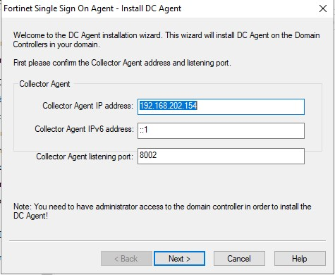
- Select domain and click Next.
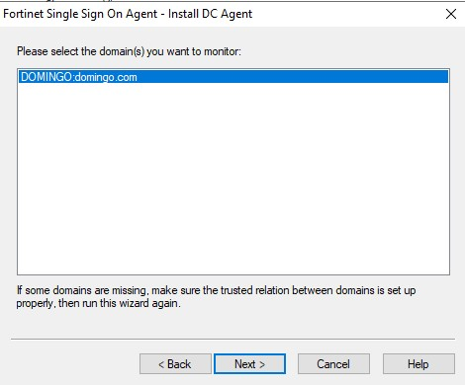
- Keep the default and just click Next until installation is finished.

4.3 Open the Fortinet Single Sign On window
- Click the Windows icon and type “Fortinet”.
- Click “Configure Fortinet Single Sign On Agent”.
- Make sure that you configure a password and the “Collector Agent Status” should be set to “RUNNING”.
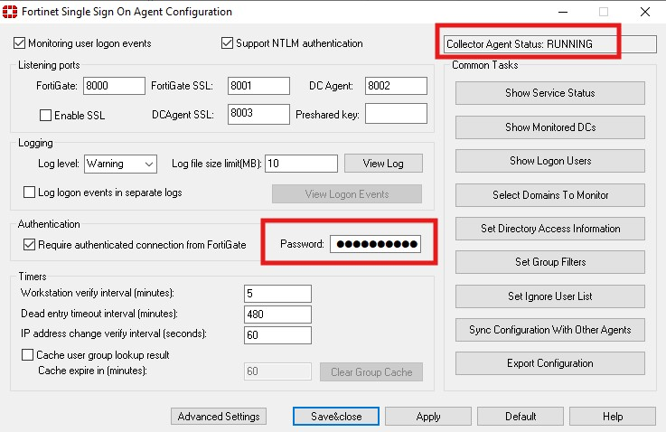
User interface of FSSO (Fortinet Single Sign On).
- If the “Collector Agent Status” is set to NOT RUNNING, click Windows icon and type “Services”.
- Navigate through “Fortinet Single Sign On Agent Service”.
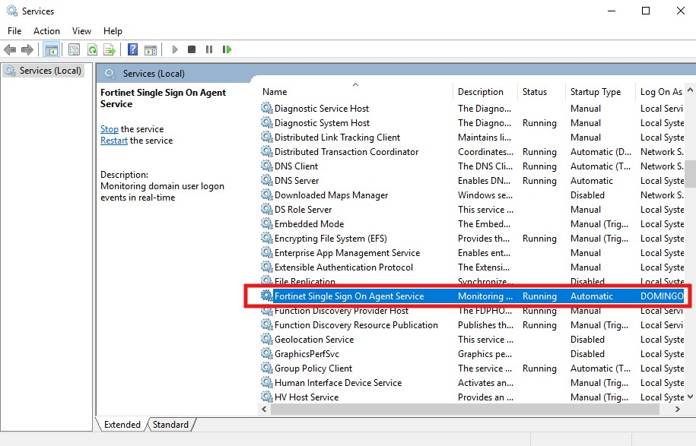
Check “Services” in case FSSO is not running.
- Double-click “Fortinet Single Sign On Agent Service”. On the “General” tab, press “Start”. On the “Log On” tab, enter the domain administrator and password.
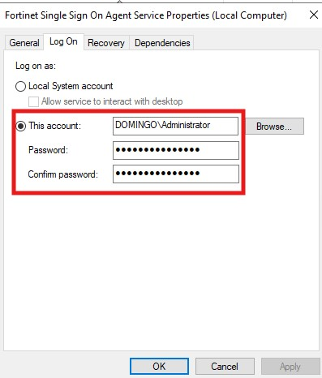
Check Log On tab.
- Let “Fortinet Single Sign On Agent Configuration” run in the background.

Check connection of Windows Server and Fortinet firewall
Since the static IP of Windows Server 2019 (192.168.202.20) is within the same network as the port1 (WAN) which is 192.168.202.0/24, run the command to check the connection of Windows Server 2019 to Fortinet firewall:
- Go to Windows Server 2019 VM.
- Open CMD and run the command “ping 192.168.202.146”. This is the IP address of Fortinet firewall.
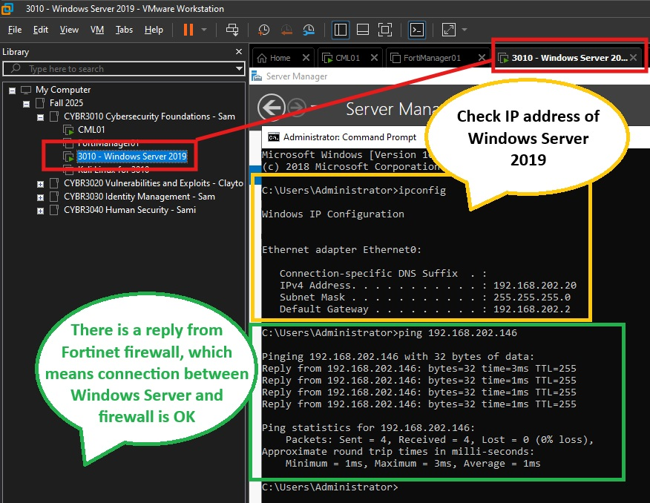
Successful connection of Windows Server 2019 and Fortinet firewall.

Adding Policies/Rules in Fortinet Firewall (8:26 in VIDEO)

Question and Answer

4.1 What is meant by “network perimeter defense” in modern enterprise networks? Explain how the traditional concept of a perimeter has evolved with cloud adoption, remote work, and mobile devices.
Network perimeter defense refers to security measures that protect an organization’s internal network from external threats by controlling traffic at the network boundary. Traditionally, this involved firewalls, intrusion detection/prevention systems (IDS/IPS), and VPNs which monitor and control traffic entering or leaving the network.
The traditional network perimeter, once a clearly defined boundary protected by firewalls, has dissolved due to cloud adoption, remote work, and mobile devices. It has been replaced by a dynamic, identity-centric approach that operates on the principle of "never trust, always verify," known as the Zero Trust security model. Unlike traditional security models that assume everything inside the perimeter is safe, ZTA treats every user, device, and application as untrusted by default, whether inside or outside the network.

4.2 Compare the capabilities of a Next-Generation Firewall (NGFW) with those of a traditional Layer 3/4 firewall. Highlight features such as application awareness, intrusion prevention, SSL inspection, and user-based policies.
A Next-Generation Firewall (NGFW) extends security to the application layer (Layer 7) through deep packet inspection and application awareness, allowing organizations to identify and control applications regardless of port or protocol. NGFWs integrate intrusion prevention systems (IPS) for real-time threat detection, support SSL/TLS decryption and inspection to uncover hidden threats and enable user-based policies by linking rules to user identities or groups rather than just IP addresses. Additionally, NGFWs leverage real-time threat intelligence for proactive defense against modern attacks like malware and ransomware, making them significantly more effective in today’s dynamic network environments.
On the other hand, a traditional Layer 3/4 firewall primarily provides packet filtering and stateful inspection based on IP addresses, ports, and protocols. It lacks visibility into application-layer traffic and cannot enforce granular controls beyond basic network parameters. These firewalls do not include integrated intrusion prevention, rely on separate IDS/IPS solutions, and cannot inspect encrypted SSL/TLS traffic. Policies are typically IP-based, offering no user identity awareness

4.3 How can NGFWs leverage threat intelligence feeds for proactive defense? Discuss the potential benefits and risks of relying on third-party threat intelligence in firewall policy decisions.
Next-Generation Firewalls (NGFWs) leverage threat intelligence feeds to enhance proactive defense by integrating real-time data on malicious IPs, domains, URLs, and attack patterns into firewall policies. These feeds, sourced from global threat intelligence platforms, allow NGFWs to automatically update rules and block emerging threats before they exploit vulnerabilities.
Benefits include faster detection of evolving threats, automated policy updates, and improved accuracy in blocking malicious traffic, which collectively strengthen an organization’s security posture. However, risks exist such as reliance on third-party intelligence that disrupt legitimate traffic, create dependency on external providers, and raise concerns about data integrity and trustworthiness of the feed. Misconfigured integrations or outdated feeds may also lead to gaps in protection or unintended blocking of critical services.

4.4 How can NGFW policies support a Zero Trust security model? Explain how concepts such as micro-segmentation, least privilege, and continuous verification can be applied at the perimeter level.
Next-Generation Firewall (NGFW) policies can significantly support a Zero Trust security model by enforcing granular controls at the network perimeter. Zero Trust operates on the principle of “never trust, always verify,” requiring continuous authentication and authorization for every user, device, and application. NGFWs enable this by applying identity-based policies, integrating with authentication systems, and inspecting traffic at the application layer. They support micro-segmentation by creating secure zones within the network and controlling east-west traffic, which limits lateral movement of threats. NGFWs also enforce least privilege by allowing access only to specific applications and resources based on user roles and device posture. Furthermore, NGFWs facilitate continuous verification through real-time monitoring, behavioral analysis, and integration with threat intelligence feeds, ensuring that trust is dynamically reassessed rather than granted indefinitely. This combination of capabilities makes NGFWs a critical component for implementing Zero Trust at the perimeter and across hybrid environments.

References

A Guide to Perimeter Defense in Modern Networks. (2025, May 20). Retrieved from Fidelis Security: https://fidelissecurity.com/threatgeek/network-security/perimeter-security-and-defense/
Cooper, S. (2025, March 24). NGFW and Zero Trust Integration. Retrieved from comparitech: https://www.comparitech.com/net-admin/ngfw-zero-trust-integration/
Integrating Third-Party Threat Feeds into Firewalls. (n.d.). Retrieved from Q-feeds: https://qfeeds.com/integrating-third-party-threat-intelligence-into-firewalls/
Janeiro, R. (2024, November 1). Enhancing Network Security with Next-Generation Firewalls. Retrieved from On Call: https://nist800171compliance.com/enhancing-network-security-with-next-generation-firewalls/
Perimeter Security. (n.d.). Retrieved from Acalvio: https://www.acalvio.com/resources/glossary/perimeter-security/
What is Zero Trust Architecture (ZTA)? (n.d.). Retrieved from paloalto: https://www.paloaltonetworks.com/cyberpedia/what-is-a-zero-trust-architecture#:~:text=Zero%20Trust%20Architecture%20(ZTA)%20is,a%20highly%20distributed%20digital%20environment.
Why Network Security Will Never Be The Same. (2025, April 25). Retrieved from Forbes: https://www.forbes.com/councils/forbestechcouncil/2025/04/25/why-network-security-will-never-be-the-same/

